
K&M Tire

Commercial Sales Managerial Duties
Version 1.0
03/15/2021

Document Number:
Contract Number:

Table of Contents
Commercial Sales Managerial Duties i
Table of Contents ii
1. K&M Tire Introduction 3
1.1 Important Company Information 5
2. Welcome 6
3. Overview 7
3.1 Conventions 7
3.2 Cautions & Warnings 7
4. Expectations 8
5. Provide training, leadership and direction to commercial specialist to increase sales and maximize gross profit 9
5.1 Conduct or be a part of commercial specialist employee evaluations. 9
5.2 Travel and conduct sales calls with the commercial specialist quarterly. 9
5.3 Provide direction to the commercial specialist on a daily basis. 9
5.4 Promote a team environment 11
5.5 Responsible for managing and resolving conflict in the work environment by using the company values as a guide. 11
5.6 Assure that competent, good quality work is being done. 12
6. Video Library 15
6.1 How to Videos 15
6.1.1 MaddenCo 15
6.1.2 Dashboard 15
6.1.3 Price Level Request 15
6.1.4 Program Request 15
6.1.5 Spot Opportunities 15
6.1.6 Credit Application 15
6.1.7 Dealer Request Form 15
6.1.8 Common Ownership Form 15
6.1.9 Release of Liability 15
Intranet 15
6.1.10 Customer Information 15
6.1.11 Sales Analysis 15
6.1.12 Ranking Report 15
6.1.13 Inventory Control 15
6.1.14 Open Closed Order 15
6.2 Weblink 15
6.2.1 Weblink Login 15
7. Conclusion 16

K&M Tire Introduction
Video about K&M Tire
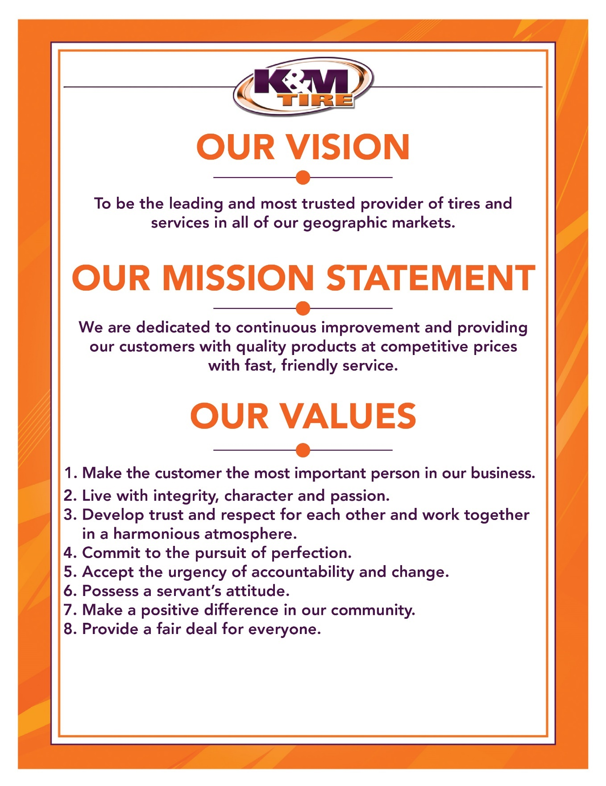

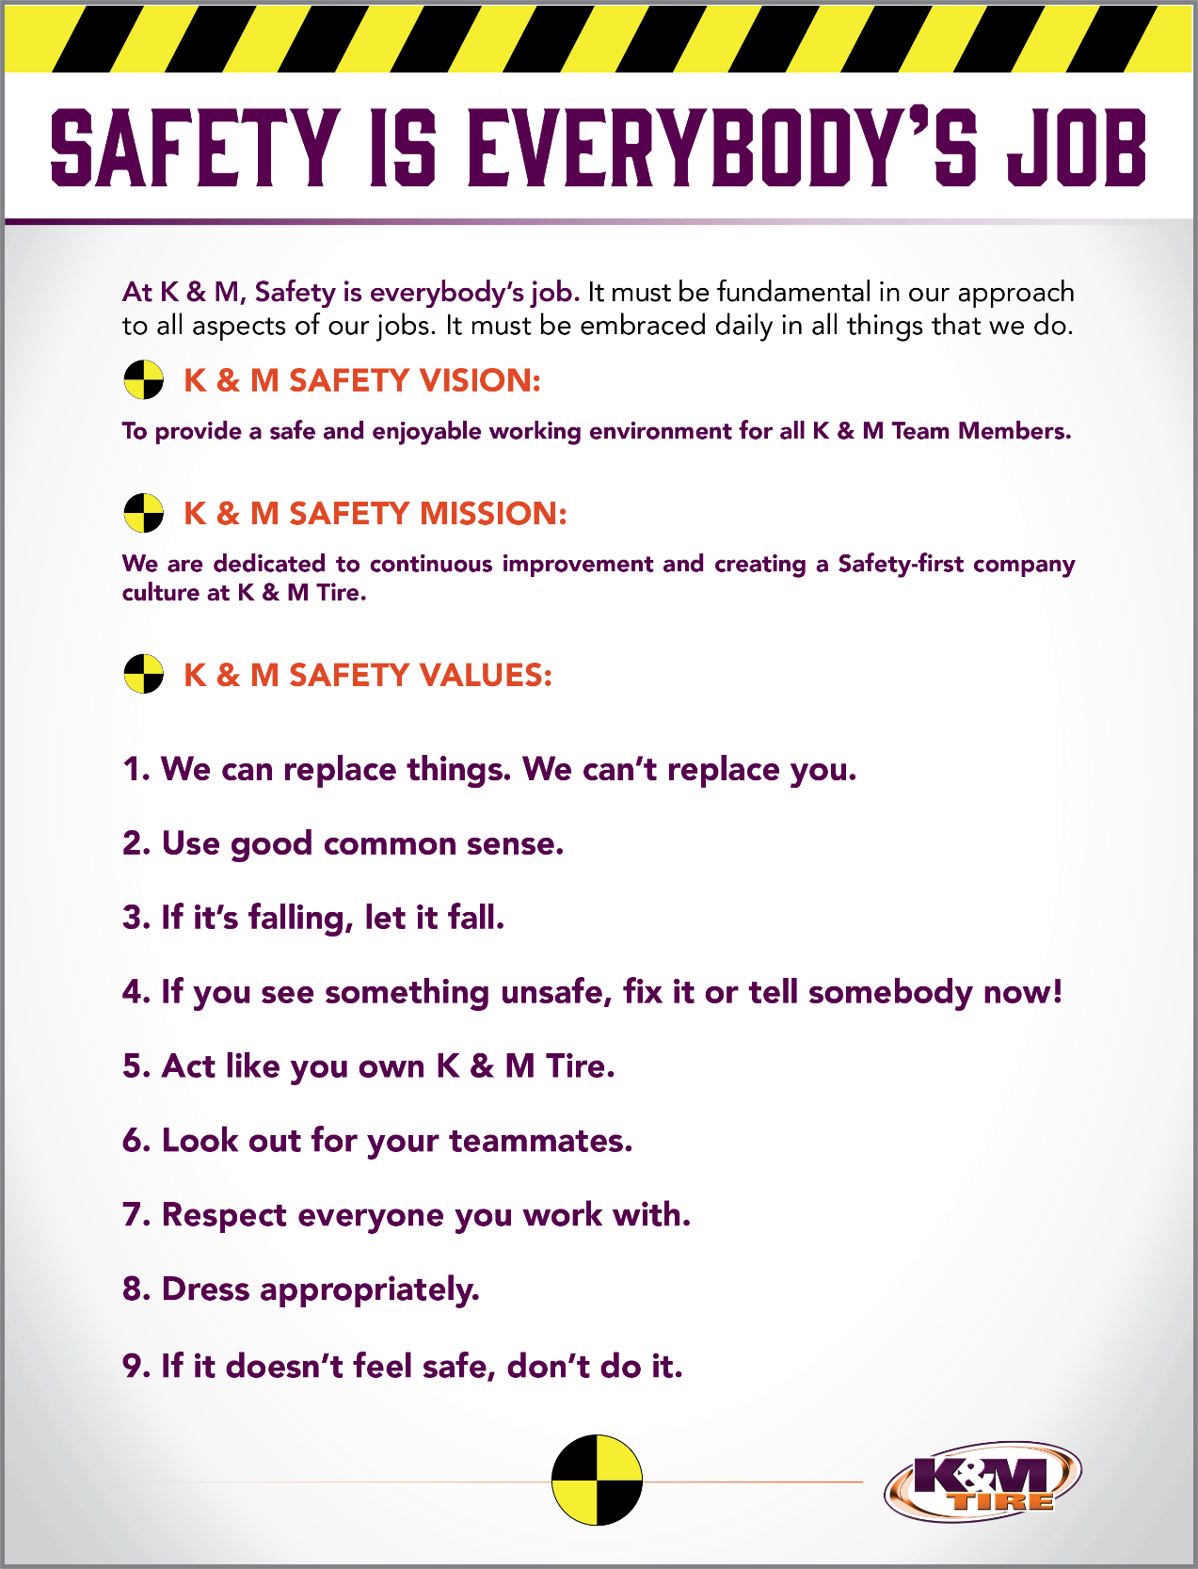

Important Company Information
This information is updated frequently. To ensure you are viewing the most current and accurate information, please use the links to access each document.

Employee Handbook
Employee Handbook can be found in Paylocity under Self – Service Portal then unemployment and is accessible HERE.

Organizational Chart
The organizational chart is a breakdown showing who is on each team and the chain of command throughout the entire company starting with the CEO and President. It is maintained on Paylocity and is accessible HERE.

Our Locations:

Warehouse Locations - Contact Information
The Warehouse Locations – Contact Information is a Word document listing each of our warehouse locations’ addresses, a phone number to reach the warehouse/manager, the manager’s name and an email address for to reach the warehouse manager directly as well as a “location” email. When sending an email to the location email address, it will be sent to anyone associated with that warehouse who has an active email address. This list is maintained by our Human Resources department and can be found on the F: Drive. You can also view the list by clicking HERE.

K&M Tire US Footprint
Click on the below link to see the footprint map
http://kmtire.com/km-cgi/distmap

Welcome
Welcome to the K&M Tire family and Commercial Sales Team! We are pleased you decided to become part of our positive culture and strive to make our company the leading and most trusted tire distributor. Our #1 Value is to make the customer the most important person in our business, and that starts with you. We have many tools to help you along the way and we understand that it can be overwhelming in the beginning. Do not hesitate to ask for help; like family we are all here to support you.
In the Commercial Specialist Sales position, you will manage current and prospective accounts within your territory. Our online ordering system is the best in the industry. Weblink 2.0 provides our tire dealers with everything they need to be successful. It is our job to show customers how to utilize Weblink 2.0 to its full potential. Telenotes will be your personal assistant and will help you stay on track with follow up tasks, scheduling, customer names, birthdays, and important account information. The intranet will give you the ability to spot opportunities quickly, keep customers up to date on programs, view customer ranking reports, and make sure customers are logging into Weblink 2.0, etc. The Dashboard allows you to see what programs a customer is on, look up purchase history, check pricing & availability, and check total sales, etc. Concur will help you keep your expenses in line and up to date. These our only a few of the great tools we have at our disposal at K&M Tire.
It would be impossible to include everything in such a short letter. For this reason, we created this S.O.P. (Standard Operating Procedure) reference guide. We will keep this up to date when processes change, but remember if you have any questions, ASK. Welcome to the team and we look forward to sharing your success!

Overview

Conventions
This document provides screen prints and corresponding narrative to describe how to use the Maddenco, Weblink and K&M Intranet, known as “company systems”
Note: The term ‘user’ is used throughout this document to refer to a person who requires and/or has acquired access to the company systems.

Cautions & Warnings
This manual does not supersede any safety or company policy.

Expectations

Commercial Specialist Sales Best Practices
This section will outline how to efficiently use the most valuable tools available to you as a Commercial Sales professional. Here you will find step by step instructions on how to successfully navigate Telenotes, Dashboard, Intranet, and Weblink 2.0. These tools when used correctly will position you to be a valued consultant to our customers and put you a step ahead of the pack. Most customers will not ask you for help, so you will need to find ways to earn trust and show your value. These tools are designed to help you do just that. It is best to possess a servant’s attitude when approaching each customer (Value #6). Showing a customer that you are more concerned for their success, than your own is great start to show your potential value to their business. Bringing profit solutions with the help of these tools will only increase your value to a customer. Take the time to learn and fully understand how to utilize these tools to enhance the customer’s experience with you.

Provide training, leadership and direction to commercial specialist to increase sales and maximize gross profit

Conduct or be a part of commercial specialist employee evaluations.
- On boarding and periodic evaluations are needed to ensure employees are developing and are aligned with company goals.

- Minimally, annual evaluation of each employee should be completed. This is required by K&M but also necessary for any employee’s development.

- New employees should receive 30-60-90 day evaluations at beginning of employment or start of new role. This helps to ensure the rapid development required in this period for the new employee.

- Evaluations should be made with transparency and honesty. Address any issues that need attention and make note of any worthy accomplishments as well.

- Evaluations should involve back and forth conversation with manager and employee. It is important that employees understand the “why” and that managers get feedback from employee.

Travel and conduct sales calls with the commercial specialist quarterly.
- The commercial sales manager works with the commercial specialist developing relationships with external and internal customers.
- The commercial sales manager is responsible for making sales calls with the commercial specialist in an effort to coach and possibly mentor them in the process.
- The commercial manager is responsible for knowing who and what the customer’s needs are. This knowledge is gained by working in the field with the commercial specialist.
- Monitor market trends throughout the company’s geographic markets while traveling with the commercial specialist.

Provide direction to the commercial specialist on a daily basis.
- Establish new customers and grow current customers.
  - The core job responsibility for commercial sales specialist is to grow commercial sales.
  - There is no “I” in team, and the team effort to find & develop customers is always more effective.
  - The team effort has a side benefit, as it allows for the commercial specialist to learn from the outside sales team as well as what is offered by the CSM.
- Maintain and grow accounts without undercutting competitors pricing.
  - K&M offers a very competitive overall value proposition to customers, part of which is pricing. There will be instances where price may need to be addressed.
  - The CSM should be keenly aware of competitor’s price strategies and service levels. Awareness doesn’t mean to focus on it. Commercial pricing can be affected by retreading. Understanding what they do can greatly help in any evaluation of need for price changes.
  - Commercial specialist should diligently follow the price level request process when they feel a price change is required to earn or maintain a customer’s business. Price Level Change Request Form
  - The CSM should vet the PLR, including discussing with the commercial specialist and potentially the customer. When the CSM determines the PLR is warranted it should be sent to Director of Sales and VP of Sales for approval. After approval, it is responsibility of the CSM and commercial specialist to monitor the impact of the PL change and adjust further if necessary (including potential retraction). If the PLR is determined to not be warranted by CSM or is denied by the Director of Sales or VP of Sales the CSM should work with commercial specialist to find a different path to follow with customer.
- Be knowledgeable of and promote the products K&M has to offer.
  - The CSM needs a good working understanding of the tire industry and various segments and products. This is necessary for both the sales effort itself as well as the effort to coach teammates.
  - The CSM should understand the seasonality of certain products in the region that is covered.
  - The CSM should understand the levels of importance within the company for certain segments, products or brands that K&M offers.
- Be knowledgeable of and promote the programs K&M has to offer.
  - The CSM, as well as anyone in outside sales, needs to have high level of understanding and completely support K&M’s in house programs.
    - Stay up to date on requirements for participation.
    - Stay updated on current promotions within the programs.
    - Maintain focus on K&M customers that participate in these programs.
    - Engage teammates in support and promotion of these programs.
  - The CSM needs to have working knowledge of K&M’s various vendor & partner programs.
    - Stay in contact with the various vendor reps for the most current information on those programs.
    - Ensure the commercial specialist are aware of what promotions are happening with each program and that the promotions are being presented to the customers and prospects.
    - Work with the commercial specialist and vendors reps to ensure customers achieve at as high a level as possible on the programs in which they participate via K&M.
    - Work with commercial specialist tracking and notifying customer’s program progress.
- Be knowledgeable of and promote K&M’s Weblink 2.0
  - Understand in detail how Weblink 2.0 works
  - Be aware of how competitor sites work and what might be different with Weblink 2.0
  - Stay up to date on changes with Weblink 2.0
  - Work with commercial specialist and customers to utilize Weblink 2.0 to its fullest capabilities.
- Work towards the BestOne motto of: Give every customer a reason to smile (outstanding customer service).
  - K&M Value #1 states to make the customer the most important person in our business.
    - Always keep customer satisfaction in mind.
    - Be aware of impact decisions that you make.
    - Don’t commit to something you cannot follow through on.
    - Set yourself and K&M up to win for the customer whenever possible.
  - Understand company policies and procedures. If you know where there is potential for trouble be proactive and work to prevent it.
    - Example would be signing up a new dealer that you know is located in an area that is at the end of route that normally finishes at 3:30pm. If the dealer tells you that getting tires early in the morning is necessary for them don’t just accept the credit application and move on. Be transparent with the dealer and explain what our level of service is so there are no surprises.

Promote a team environment
- Lead by example. Whenever possible, work with commercial specialist in their region. Make the effort to be collaborative as possible.
- Encourage teamwork with the outside rep’s and regional managers of the region. The positions are solitary in many ways, but, the commercial specialist will be more successful working together with everyone else assigned to the region when opportunities present themselves.
  - Over time, leadership and mentoring roles will develop within the commercial specialist group which can lead to development of future managers.
- Encourage teamwork at the outside rep level outside the group. Commercial specialist is often going to have more opportunities to work closely with inside sales, warehouse or driver teammates than the CSM will.
- A positive relationship between commercial specialist outside sales reps region manager and teammates outside the group can only benefit the commercial specialist, the sales team and K&M Tire.

Responsible for managing and resolving conflict in the work environment by using the company values as a guide.
- Don’ be surprised that on occasion tensions will flare up between teammates or with customers.
  - If conflict involves a customer, keep in mind the effort to make the customer the most important person in our business.
  - If you purport yourself with integrity this trait will show through as you endeavor to resolve conflict.
  - When these events arise, trying to nurture feelings of trust and respect between the parties involved to help lessen chance of further conflict.
  - Sometimes conflict can be the result of good intentions on all sides. Encourage the effort to continually improve things.
  - When disruptions or tension arise over conflict you have a responsibility at that moment to help correct the situation. Furthermore, you have a responsibility to mentor teammates involved to recognize that they also have the same responsibility.
  - Don’t be afraid to get your hands dirty. You may have to dive into the situation and dig around to find out how best to help.
  - Don’t let yourself be the source of conflict. Bad habits can arise and you may not even recognize it is happening. Hints can show themselves, and this is good time for some retrospection. If you find a habit you have does lead to conflict then there is no time like the present to start working to change.
  - At the end of the day, everyone involved is not always going to be happy with final resolution to the conflict. The CSM should work to make sure the resolution if fair to all parties as much as possible.
  - Lead by example coaching and promoting resolutions to maintain a positive work place.

Assure that competent, good quality work is being done.
- K&M offers a number of tools that can help you in monitoring and evaluation of the work being done by the commercial specialist.
  - Telenotes is a key tool that should be a part of your day, every day.
    - Read the Telenotes of the commercial specialist team leaves each day.
    - Provide any valuable feedback to the content of the various notes.
    - Take note of the quantity of notes left. Not all sales territories are created equal, but you and your reps should have a good understanding of the numbers of calls per day, on average that are required. If you need help in establishing a set number get with the VP of Sales of some instructions.
  - Also use Logitrac to assist you in monitoring daily activity.
    - With Logitrac you can see if a rep is fully covering the assigned territory.
    - You can determine if too much or too little time is sent in given areas.
    - You can use to monitor daily start and stop times as needed.
    - You can compare to Telenotes to see if there are any discrepancies.
    - You can provide an overview to help plan future routing of calls.
  - Use the various intranet reports to track sales results.
    - These reports don’t tell much day to day, but overtime you can see trends.
    - Intranet reports on sales results can show you and reps areas that need attention.
- A good practice would be to have the commercial specialist on your team forward any important documents like credit apps or programs forms to you first, or at least, a copy you in on these at time of forwarding.
  - You can inspect and ensure the forms are completed properly. This saves time for those in other departments.
  - You can coach the reps on your team on what is needed.
- Engage the commercial specialist on your team on what is needed.
  - Stay up to date on what troubles they have with customers or programs.
    - Be proactive here, don’t wait for them to reach out to you.
  - Talk about what the rep does well. Let him or her know that you know about the successes and encourage more.
  - Collaborate on a game plan.
    - Being involved does not mean you are micro managing.
    - Show that you care in the reps success.
  - Foster a relationship with the commercial specialist where you can be made aware of any outside influences that impact, the work being done.
    - There is fine line between intrusiveness and caring
    - Don’t be swayed from showing that you care.
- At the conclusion of each month, the CSM needs to submit a monthly report on region sales activities to the Admin department as well as the VP of Sales and Director of Sales.
  - Monthly report to include the following sections:
    - Training summary for each commercial specialist & plan for the following month.
    - Telenotes summary for each CS
    - Detailed Logitrac (or Samara) map showing travels by the CS rep.
    - Road to Excellence (S.W.O.T) (Strengths, Weaknesses, Opportunities, Threats) summary with examples of how a particular CS rep or the CS team addressed.
    - Detailed report on the progress being made with each CS selected target accounts.
    - Feedback section.
  - This report needs to be submitted in the agreed upon format (spelled out by VP of Sales) by the 10th of the following month.
- Present a clean, neat, professional appearance.
- Work closely with K&M management.
  - Within the Sales & Marketing department it is vitally important that you have good working relationship with VP of Sales, Director of Sales, Marketing, VP of purchasing, Inside Sales Manager, Marketing Manager, Regional Sales Managers, Ag Sales Manager, Car Dealer Sales Manager and other department managers.
  - Actively seek opportunities to work together with managers in other departments. K&M’s success depends upon it.
    - At the regional level a collegial relationship between the Regional Sales Manager and Regional Operations Manager is very beneficial to K&M Tire.
- Make good business decisions to help K&M be successful now and in the future.
  - If you are not sure of which direction to go, seek out advice from other managers or VP of Sales.
- Must support company goals.
  - Alignment with the direction the company is proceeding in is key.
  - Ultimately, we need to all pull in the same direction.
  - Promote this effort with the Outside Sales team and others.
- Manage outside sales rep schedules and PTO.
  - Approve weekly schedules, time cards and PTO requests via Paylocity.
- Monitor outside sales rep expenses.
  - Approve monthly expenses submitted via Concur.
    - Coach employees when you see issues with expenses in regards to what is permissible and what is not as well as what might be excessive or unnecessary.

Video Library
All of the following videos are located on K&M Tire’s very own Video Website. Click HERE to be directed to the webpage. From this point, you will see multiple videos. Each video will require a password to view it. The password for all of the following videos is: kmtire1970

Each of the below titles are videos you can find that on the referenced website. They will aid in your understanding of what each document/system/report is used for, as well as how to successfully utilize each.

How to Videos

MaddenCo

Dashboard

Price Level Request

Program Request

Spot Opportunities

Credit Application

Dealer Request Form

Common Ownership Form

Release of Liability

Intranet

Customer Information

Sales Analysis

Ranking Report

Inventory Control

Open Closed Order

Weblink

Weblink Login

Conclusion
K&M Tire is dedicated to continuous improvement. This means as our industry changes so must we. Core value # 5 Accept the urgency of accountability and change. What we do 5 years from now will be different than we do today. Keep an open mind and continue to fine tune skills. We will succeed for another 50 year as long as we live or Vision, Mission and Values. Never forget we started in a 2-bay gas station.

Appendix A: Referenced Documents
Table 1 - Referenced Documents
Document Name | Document Location and/or URL | Audit Schedule | Last Reviewed
Blank W-9 | F:\Credit & Collections\Public\Tax Forms\Blank W-9.pdf | Government  Provided | n/a
K&M Account Application | F:\Credit & Collections\Public\Credit\Account Application - K&M Tire.pdf | Annually | 10/31/2018
Release of Liability | F:\Credit & Collections\Public\Credit\ReleaseOfLiability.pdf | Annually | 12/5/2017
Common Ownership Form | F:\Credit & Collections\Public\Credit | Annually | 10/5/2021
Price Level Change Request Form | F:\Sales\Public\Sales SOP\Price Level Change Request Form.xlsx
Dealer Request Application | F:\Credit & Collections\Public\Credit\Dealer Request Fillable.pdf | Annually | 9/21/2018

